CMIS 141 – Homework 1
Ben Brandhorst
October 31st 2018

Input | Expected Output | Actual Output | Pass?
EMPLID: 123456  Quiz1: 90  Quiz2: 80  Quiz3: 70  Age in months: 400  Temperature in Celsius: 32 | Thank You For Your Inputs!  Your student EMPLID: is: 123456  Your quiz 1 score is: 90.0  Your quiz 2 score is: 80.0  Your quiz 3 score is: 70.0  Your average quiz score is: 80.0  Your age in months is: 400  Your age in years is: 33  The temperature in Celsius is: 32.0°  The temperature in Fahrenheit is: 89.6° | Thank You For Your Inputs!  Your student EMPLID: is: 123456  Your quiz 1 score is: 90.0  Your quiz 2 score is: 80.0  Your quiz 3 score is: 70.0  Your average quiz score is: 80.0  Your age in months is: 400  Your age in years is: 33  The temperature in Celsius is: 32.0°  The temperature in Fahrenheit is: 89.6° | YES
EMPLID: 999999  Quiz1: 0  Quiz2: 100  Quiz3: 0  Age in months: 1440  Temperature in Celsius: 0 | Thank You For Your Inputs!  Your student EMPLID: is: 999999  Your quiz 1 score is: 0.0  Your quiz 2 score is: 100.0  Your quiz 3 score is: 0.0  Your average quiz score is: 33.33  Your age in months is: 1440  Your age in years is: 120  The temperature in Celsius is: 0.0°  The temperature in Fahrenheit is: 32.0° | Thank You For Your Inputs!  Your student EMPLID: is: 999999  Your quiz 1 score is: 0.0  Your quiz 2 score is: 100.0  Your quiz 3 score is: 0.0  Your average quiz score is: 33.333333333333336  Your age in months is: 1440  Your age in years is: 120  The temperature in Celsius is: 0.0°  The temperature in Fahrenheit is: 32.0° | YES
EMPLID: -5  Quiz1: 101  Quiz2: 105  Quiz3: 108  Age in months: 1450  Temperature in Celsius: -5 | Thank You For Your Inputs!  Your student EMPLID: is: -5  Your quiz 1 score is: 101.0  Your quiz 2 score is: 105.0  Your quiz 3 score is: 108.0  Your average quiz score is: 104.67  Your age in months is: 1450  Your age in years is: 120  The temperature in Celsius is: -5.0°  The temperature in Fahrenheit is: 23.0° | Thank You For Your Inputs!  Your student EMPLID: is: -5  Your quiz 1 score is: 101.0  Your quiz 2 score is: 105.0  Your quiz 3 score is: 108.0  Your average quiz score is: 104.66666666666667  Your age in months is: 1450  Your age in years is: 120  The temperature in Celsius is: -5.0°  The temperature in Fahrenheit is: 23.0° | YES

Test Case 1 Inputs & Outputs
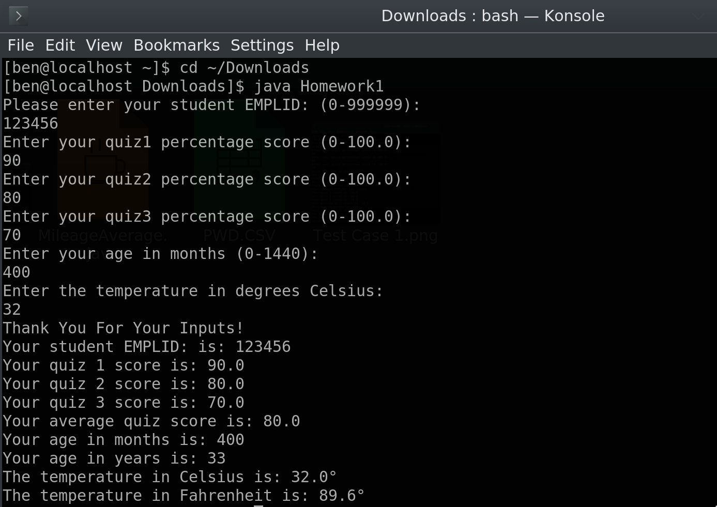

Test Case 2 Inputs & Outputs
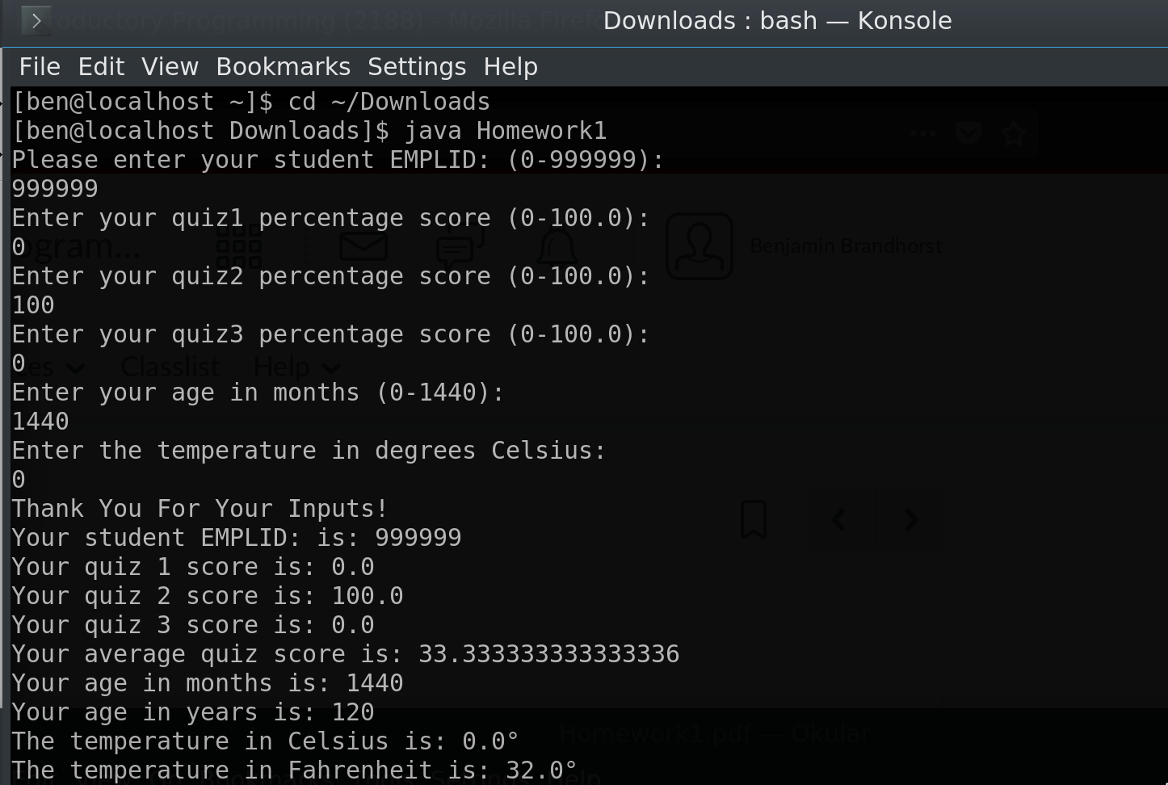

Test Case 3 Inputs & Outputs
